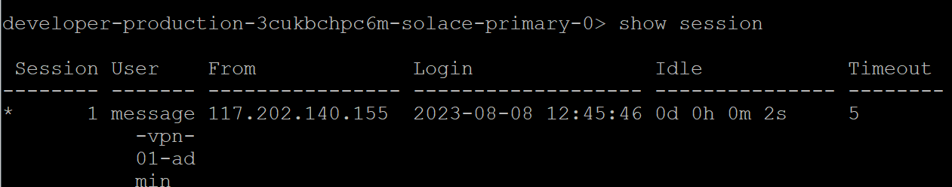  
3. Solace CLI --> show session :: What is the default unit of the Timeout?

The default unit of the Timeout is Minutes.